Connor-Francis McGrath

216869133

**Project 3**

When it came to the theme of change or transformation. I chose to take it in a very personal matter. Growing up, we are told to try as many different hobbies and activities as possible, and that this diversity is good for you. However, as I get older I often feel pressured to choose one avenue to specialize in if I want any chance of keeping up with my contemporaries. I feel pressured to give up the things I am passionate about to choose one. This animation is an exploration of those feelings, and the solution I chose. In the animation there are different coloured boxes that the character interacts with, representing different hobbies and interests. The short animation starts out very whimsically, with the character figuring out and enjoying these different activities, like I did as a kid. At around the 7 second mark there comes a dramatic change. The lighting goes from soft and colour to harsh and monochrome. This is meant to portray the stress and pressure I felt when I started to grow up to decide what I want to do with my life. Near the end, after the character falls to the floor after being overwhelmed, we see the 5 boxes combine together into one white box. This is how I chose to represent the solution I came to when I was in high school. Instead of disregarding my passions, I found something that combined them, so I wouldn’t have to lose something important to me that makes up a part of my identity. For me this was game development. It combined my loves of coding, animation, voice acting, and writing. It was the light in my dark times of confusion. This is the reason I titled my animation “A Brighter Future”. I made this animation not only to illustrate the change that was going on around me, but the change in mindset I had that allowed me to find what I was passionate about.

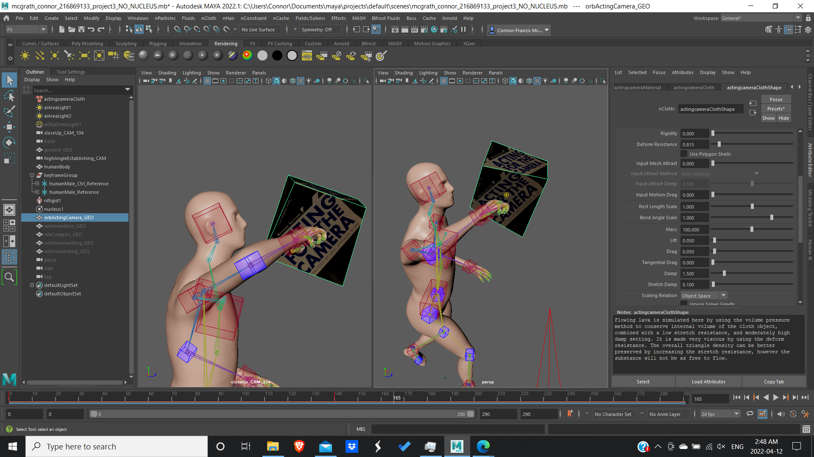

Starting the project I knew I wanted to use nCloth. In the beginning the character taps one of the cubes and it reacts. To do this I attached an nCloth to the cube, set the nucleus gravity to 0 so that the cube didn’t fall. I wanted something that deformed and then went back to being rigid. So I keyframed the cube to initially be the lava preset when it gets poked, then immediately after transitioning to the denim preset.

Using nCloth was easily the most difficult part of the entire project. My biggest problem was that Maya was constantly crashing after I tried to do anything. It was then that I realized that my render cache was on and was constantly trying to cache the entire 480 second timeline. After realizing that I was careful enough not to run out of allocated memory, either by turning off the cache or limiting the range of the timeline.

I also found that I could not translate the objects with nCloth with the move tool, the pivot would move but not the object itself. In order to circumvent this I created a duplicate object that did not have the nCloth attached whenever I wanted to move the object. In order to make sure the object didn’t fly off after being tapped by the character, I turned the drag on the nCloth to 200 so it wouldn’t move in the air.

Because physics simulations are so new to me, the process of applying them to this animation usually went: read the description of an attribute, guessing what effect it will have, and undoing if it does not do what I wanted it to.

Then I focused on the character movement. I really wanted to make sure I nailed the principles of animation. In order to accomplish this I made sure that every action had the proper set up and anticipation, the body parts move in non-mechanical arcs, making sure every action did not stop abruptly and had the proper recoil, and that the actions of one body part affects others in its proximity with drag and overlapping action. For example, when the arm swings outward, the chest opens up slightly after the arm starts moving. I had this in my mind every time I keyframed the character, to the point where I got worried if I was overdoing it. For several actions, I filmed videos of myself for reference, but for the ones I didn’t I tried guessing how long it would take. My limited knowledge in animation, combined with having Maya playing every frame instead of 24fps, as I was using nCloth, made timing nearly impossible.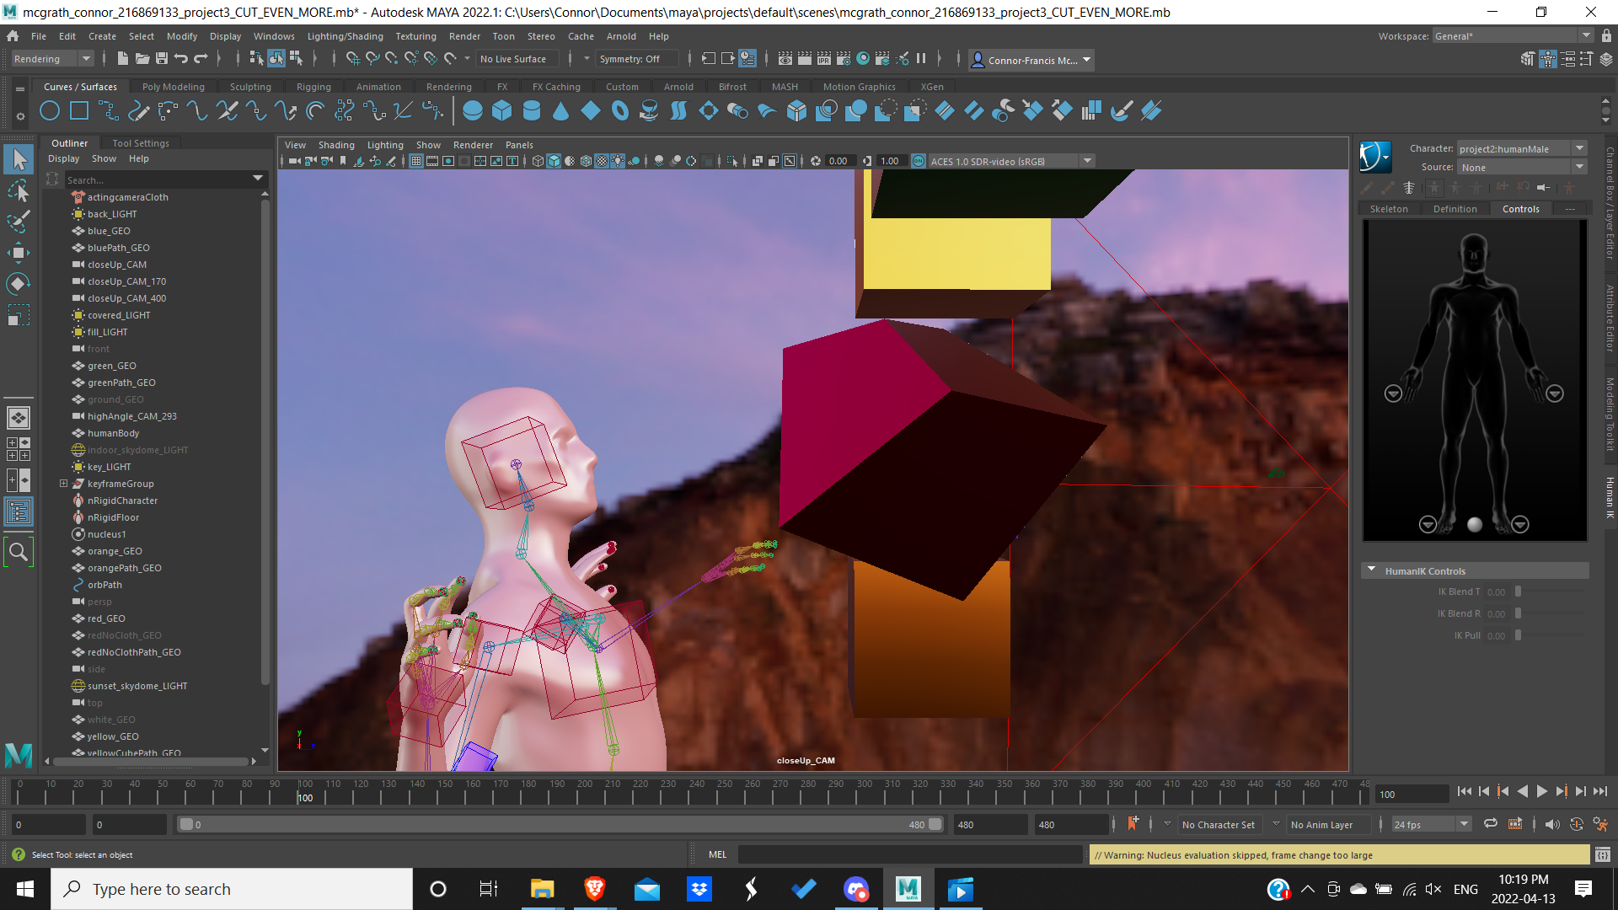

The first several times I thought I was completed, I saw that my actions in my playblast were so fast I could barely register them happening. This resulted in a huge overhaul of my original plan, as I had to get rid of many of the actions that happened in order to stretch out the time between the remaining actions. Originally when I began, I thought filling up 20 seconds would be impossible, but I did it without even trying. I underestimated how limiting that time limit was.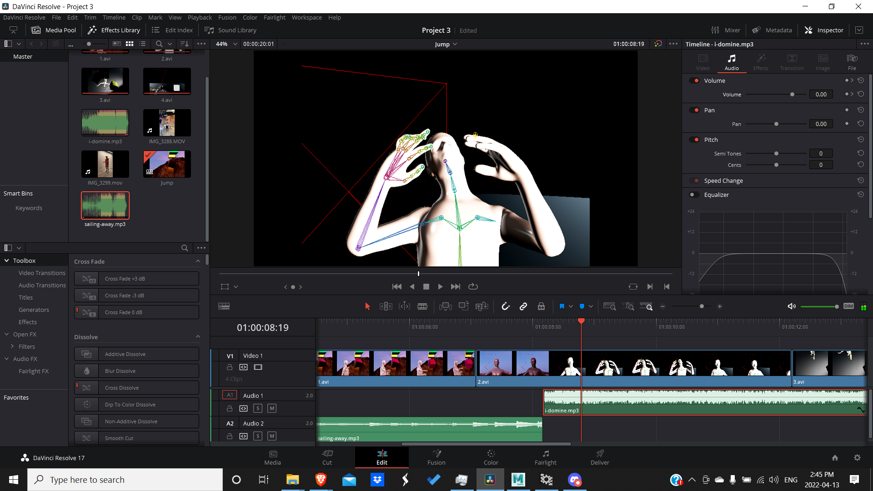

After I finished the movement I decided to focus on the camera angles. When it came to framing, I used close up shots when I wanted to highlight emotions and reactions, and wider shots when I wanted to highlight actions. In the first shot, I wanted a balance between both reactions and the motion of the action, so I used a mid shot.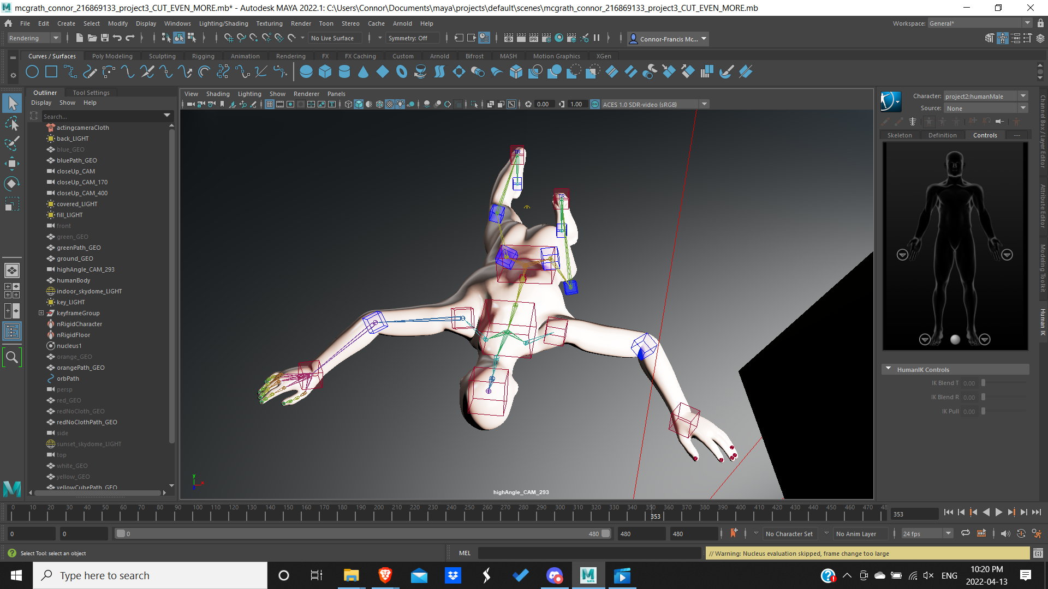

The next shot was a close up because I wanted to highlight the shock and fear of the character, letting the gestures take up the whole screen.

The character falls over, and we get a full shot of the body on the floor. I had it be a high angle shot because I wanted to portray a sense of weakness and vulnerability, and make the audience fear for what’s going to happen next.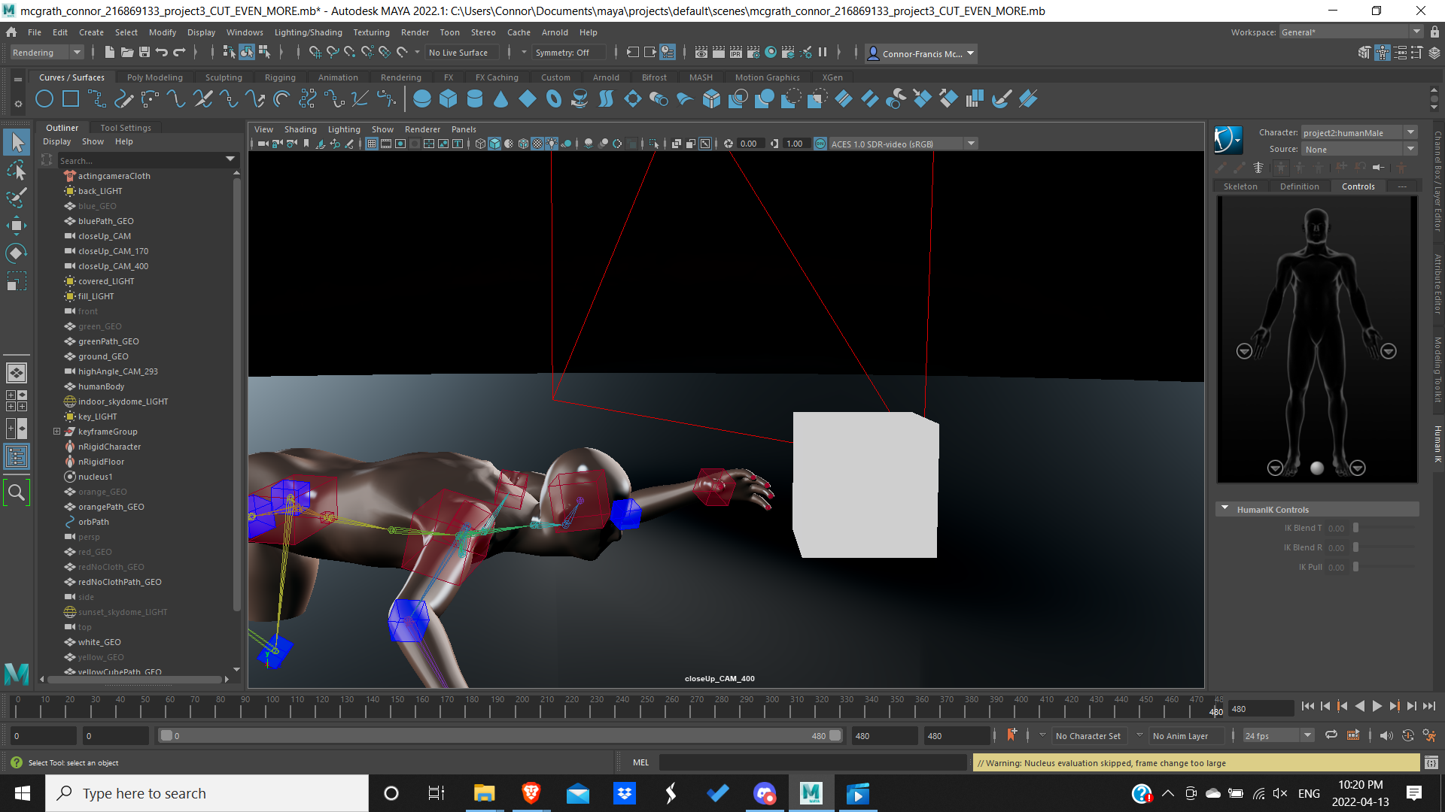

The camera then zooms out and the audience sees the boxes from the beginning moving in a circular NURBS path, converging onto each other. Here the audience sees the metaphor for all of the interests and passions combining together into one. When I tried to create a circular path for the orbs to follow. I found out Maya would not let me because of the keyframes I added to the orbs. So I created duplicates without keyframes and attached those to the path instead.

After the cluster of cubes flies off screen a new white box comes in. The camera cuts to a medium shot and tilts down in order to give a greater sense of intimacy when the character reaches out towards the white cube.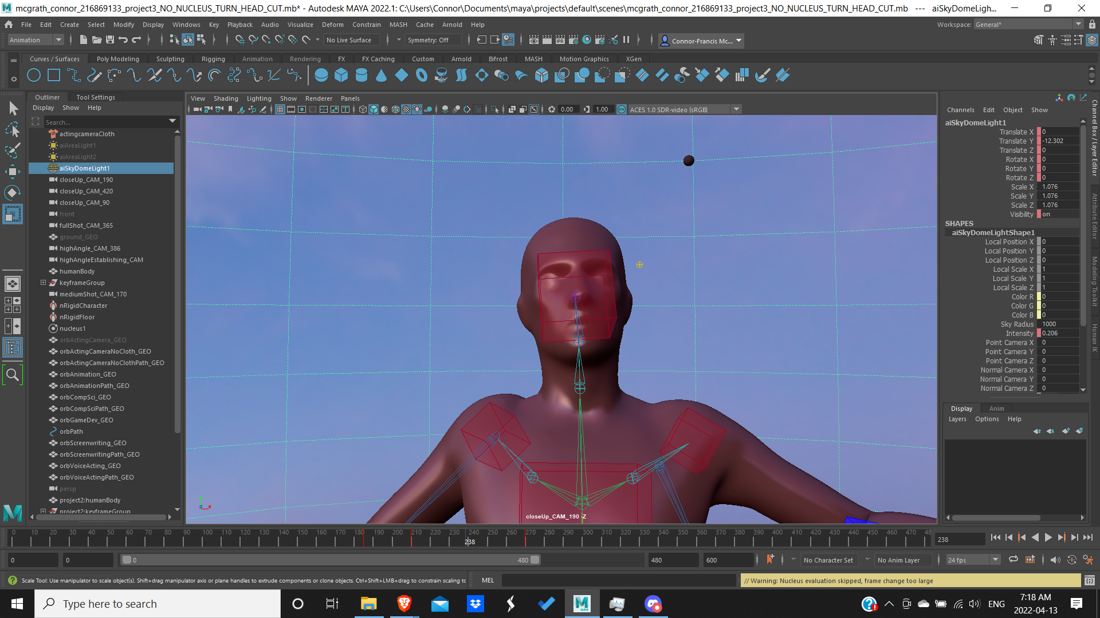

Then I worked on the lights. I used the Pink Sunrise [3] HDRI in the beginning because of its soft lights and colours. The second HDRI I used was called Studio Small 02 [4]. I used this HDRI because its lighting had a very cold and industrial feel, and when the lights were low it would look at though the character was in an empty void.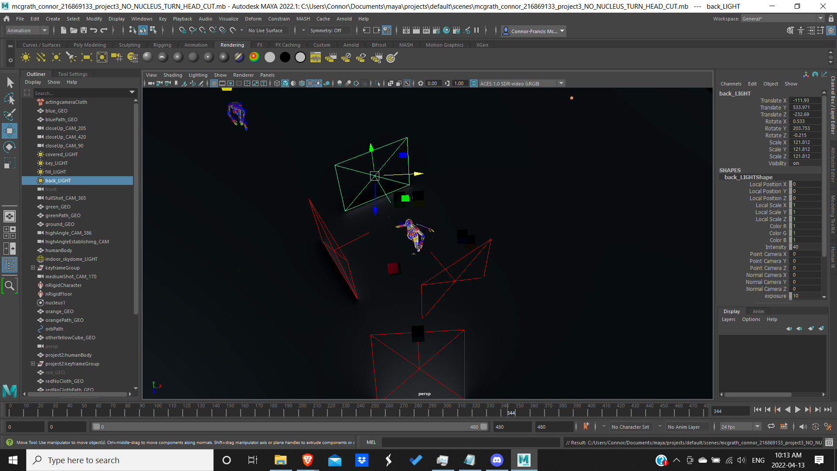

While in the Studio HDRI, the character is lit with 3 point lighting. The key light was intense and uncomfortable, the fill light is very low so that there are pronounced shadows, and the backlight was set to a moderate exposure to ensure the character was separate from the background.

When I added music I used the song “Sailing Away” [1] because it had an ethereal feel to it that fit the carefree wonder of enjoying things as a kid. The song, along with the lights, change out of nowhere, as it often feels in real life, to the song “I Domine” [2] which is very intense. However, I chose to use the end of the song, as intensity fades and subtly hints that things are looking hopeful for the protagonist even as the darkness creeps in.

Another change I made at the end was changing the textures on the objects. At first they were covers of books that I owned in order to spell out what my passions and interests were. However, I thought it would make the animation more entertaining if it was more abstract and open to interpretation from the audience. So I decided to just use shaders.

Works Used

1. Ivers, Shane. “Sailing Away.” *Silverman Sound*, <https://www.silvermansound.com/free-music/sailing-away>. Accessed 13 Apr. 2022.
2. Ivers, Shane. “I Domine.” *Silverman Sound*, <https://www.silvermansound.com/free-music/i-domine>. Accessed 13 Apr. 2022.
3. Zaal, Greg. “Pink Sunrise.” *Poly Haven*, Poly Haven, 29 Nov. 2017, <https://polyhaven.com/a/pink_sunrise>. Accessed 13 Apr. 2022.
4. Zaal, Greg. “Studio Small 02.” *Poly Haven*, Poly Haven, 22 Mar. 2018, <https://polyhaven.com/a/studio_small_02>. Accessed 13 Apr. 2022.